

INDIAN INSTITUTE OF INFORMATION TECHNOLOGY, DHARWAD

SUBMITTING TO:

Prof. Dr.VIJAYA.C

DIGITAL SIGNAL PROCESSING

Dept. of ECE

TABLE OF CONTENTS

|  |
| --- |
| 1. Introduction |
| 1. Literature Survey |
| 1. Overview of the algorithm |
| 1. Algorithm |
| 1. Experiments and Result |
| 1. Conclusion |

INTRODUCTION :

IMAGE SEGMENTATION

In digital image processing and computer vision, image segmentation is the process of partitioning a digital image into multiple segments (sets of pixels, also known as image objects). The goal of segmentation is to simplify and/or change the representation of an image into something that is more meaningful and easier to analyze. Image segmentation is typically used to locate objects and boundaries (lines, curves, etc.) in images.

Image Segmentation methods assumes that:

1. Intensity values are different in different regions.
2. With each region, which represents the corresponding object in a scene, the intensity values are similar.

It includes Threshold property, where threshold is used to extract an object from its background by assigning an intensity value ‘T’ for each pixel such that each pixel is either classified as an object or background point.

LITERATURE SURVEY

* Dongju Liu , Jian Yu “ OTSU and K-means “ .

Published in: **2009 Ninth International Conference on Hybrid Intelligent Systems.**

**(IEEE Xplore)**

* Jun Zhang , Jimglu Hu “Image Segmentation Based on 2D Otsu Method with Histogram Analysis”.

**Published in: 2008 International Conference on Computer Science and Software Engineering.**

* OTSU method – WIKIPEDIA
* <https://in.mathworks.com/help/images/ref/graythresh.html#description>

OVERVIEW : OTSU ALGORITHM

In computer vision and image processing, Otsu's method, named after Nobuyuki Otsu , is used to perform automatic image thresholding. In the simplest form, the algorithm returns a single intensity threshold that separate pixels into two classes, foreground and background. This threshold is determined by minimizing intra-class intensity variance, or equivalently, by maximizing inter-class variance. And is equivalent to a globally optimal k-means performed on the intensity histogram. The extension to multi-level thresholding was described in the original paper, and computationally efficient implementations have since been proposed.

**graythresh** Global image threshold using Otsu's method.

LEVEL = **graythresh**(I) computes a global threshold (LEVEL) that can be

used to convert an intensity image to a binary image with IMBINARIZE.

LEVEL is a normalized intensity value that lies in the range [0, 1].

**graythresh** uses Otsu's method, which chooses the threshold to minimize

the intraclass variance of the thresholded black and white pixels.

ALGORITHM :

Test image 1:

close all;

I=imread('mri.tif');

figure,imshow(I);

figure,imhist(I);

T=55;

It=im2bw(I,T/255);

figure,imshow(It);

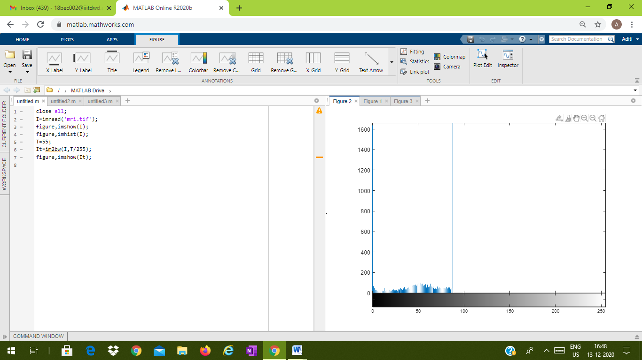



close all;

I1=imread('mri.tif');

%I1=rgb2gray(I);

imshow(I1);

figure,imhist(I1);

T2=graythresh(I1);

it2=in2bw(I1,T2);

figure,imshow(it2);

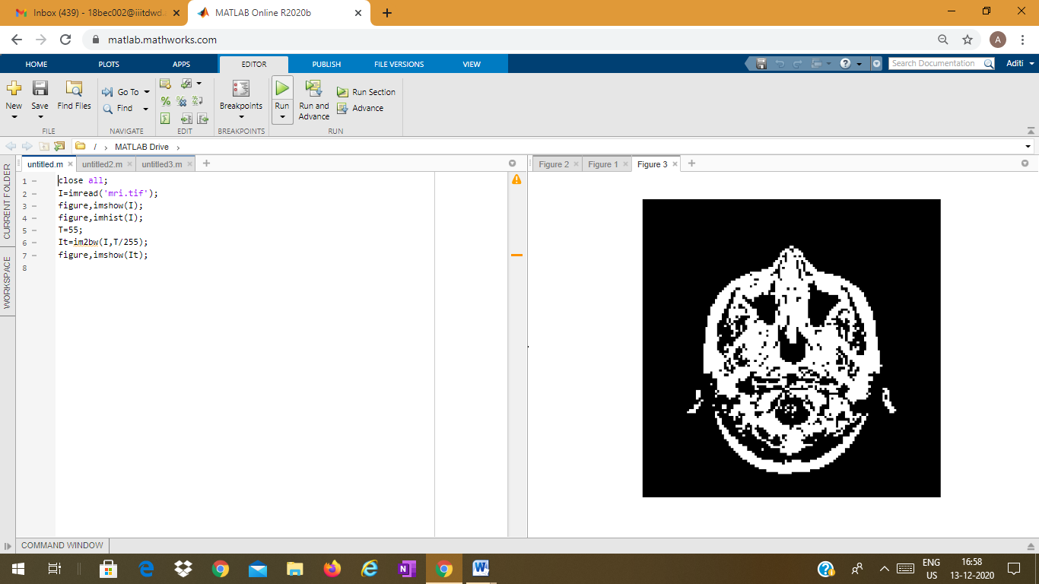

Test image 2:

close all;

I=imread('rice.png');

figure,imshow(I);

figure,imhist(I);

T=140;

It=im2bw(I,T/255);

figure,imshow(It);

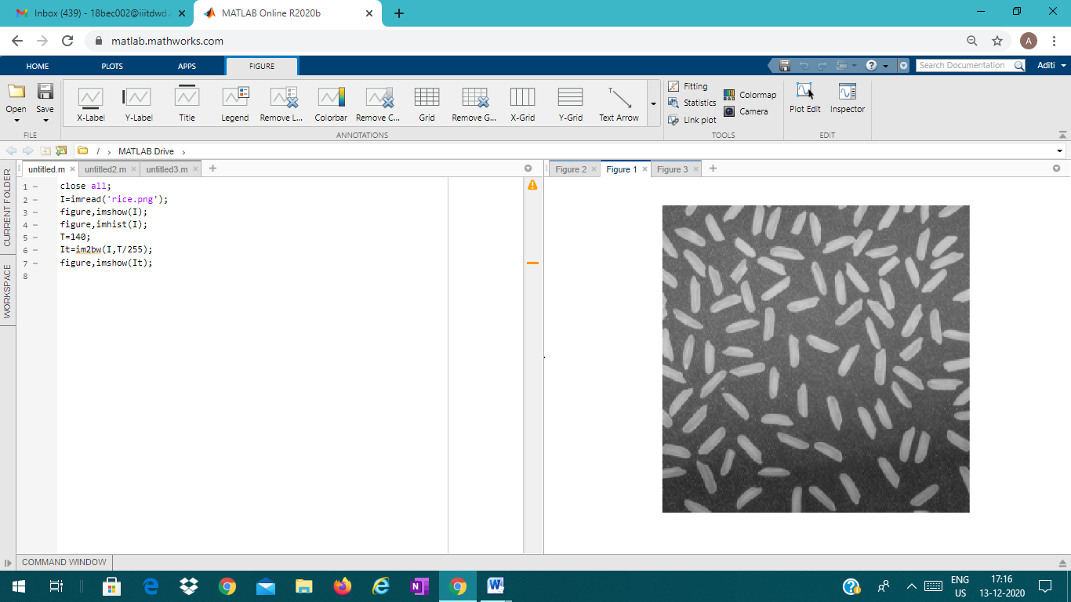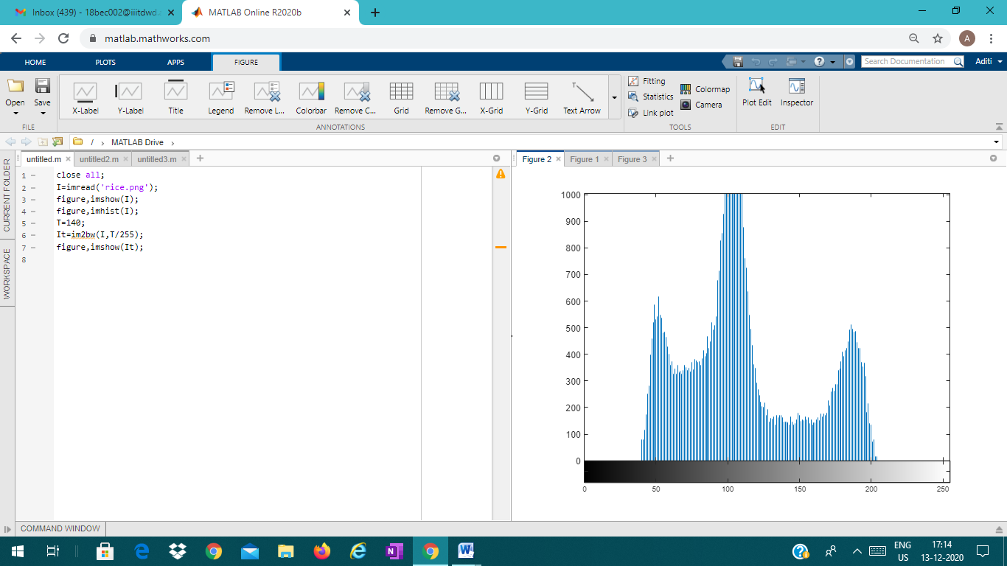

close all;

I1=imread('rice.png');

%I1=rgb2gray(I);

imshow(I1);

figure,imhist(I1);

T2=graythresh(I1);

it2=in2bw(I1,T2);

figure,imshow(it2);

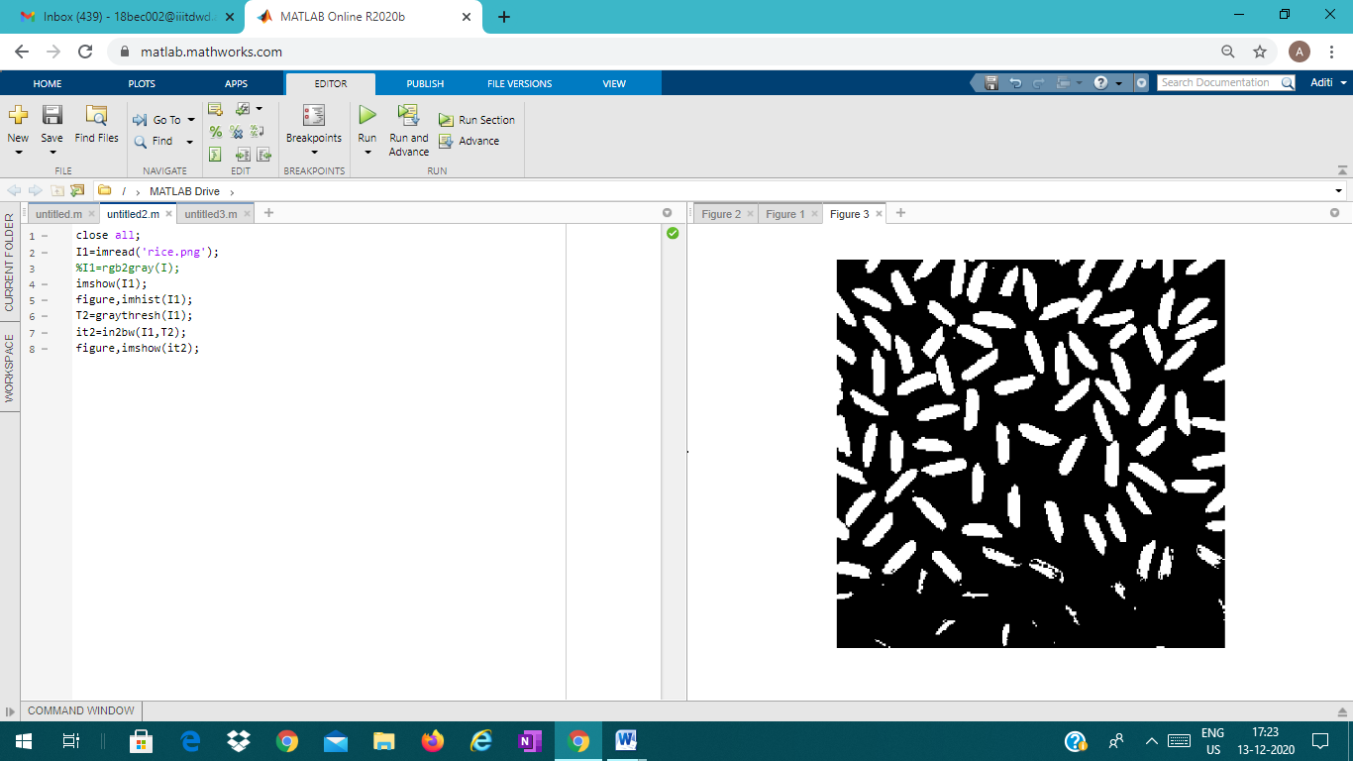

RESULT

Otsu's method exhibits the relatively good performance if the histogram can be assumed to have bimodal distribution and assumed to possess a deep and sharp valley between two peaks. But if the object area is small compared with the background area, the histogram no longer exhibits bimodality. Various extensions have been developed to address limitations of Otsu's method. One popular extension is the **two-dimensional Otsu's method**, which performs better for the object segmentation task in noisy images. Here, the intensity value of a given pixel is compared with the average intensity of its immediate neighborhood to improve segmentation results. ,

THANK YOU

SUBMITTING BY :

18BEC001

18BEC002

18BEC008